**Requirements and User Stories**

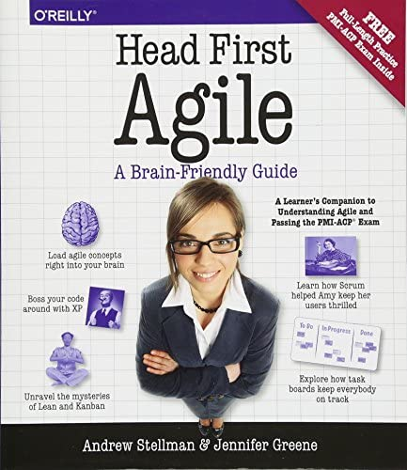

We needed to understand the process of Scrum, so we read the first chapters of a book called “Head First Agile: A Brain-Friendly Guide to Agile Principles, Ideas, and Real-World Practices”. Here we understood how other teams organize their work based on User Stories and we made them based on this type of cards:

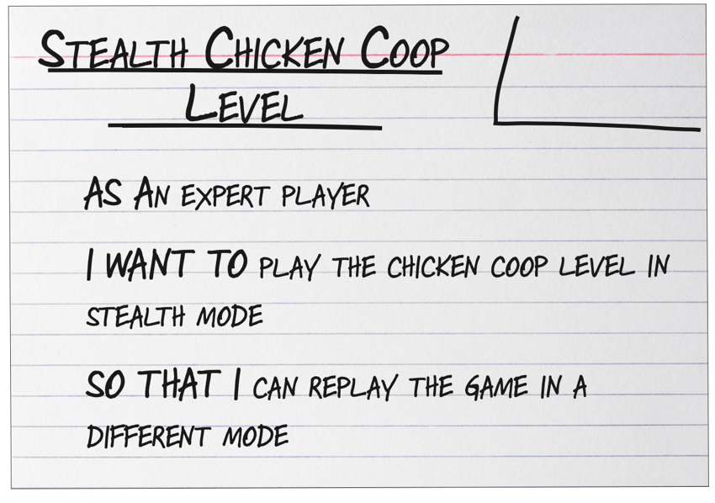

This are the User Stories we determined we needed to develop:

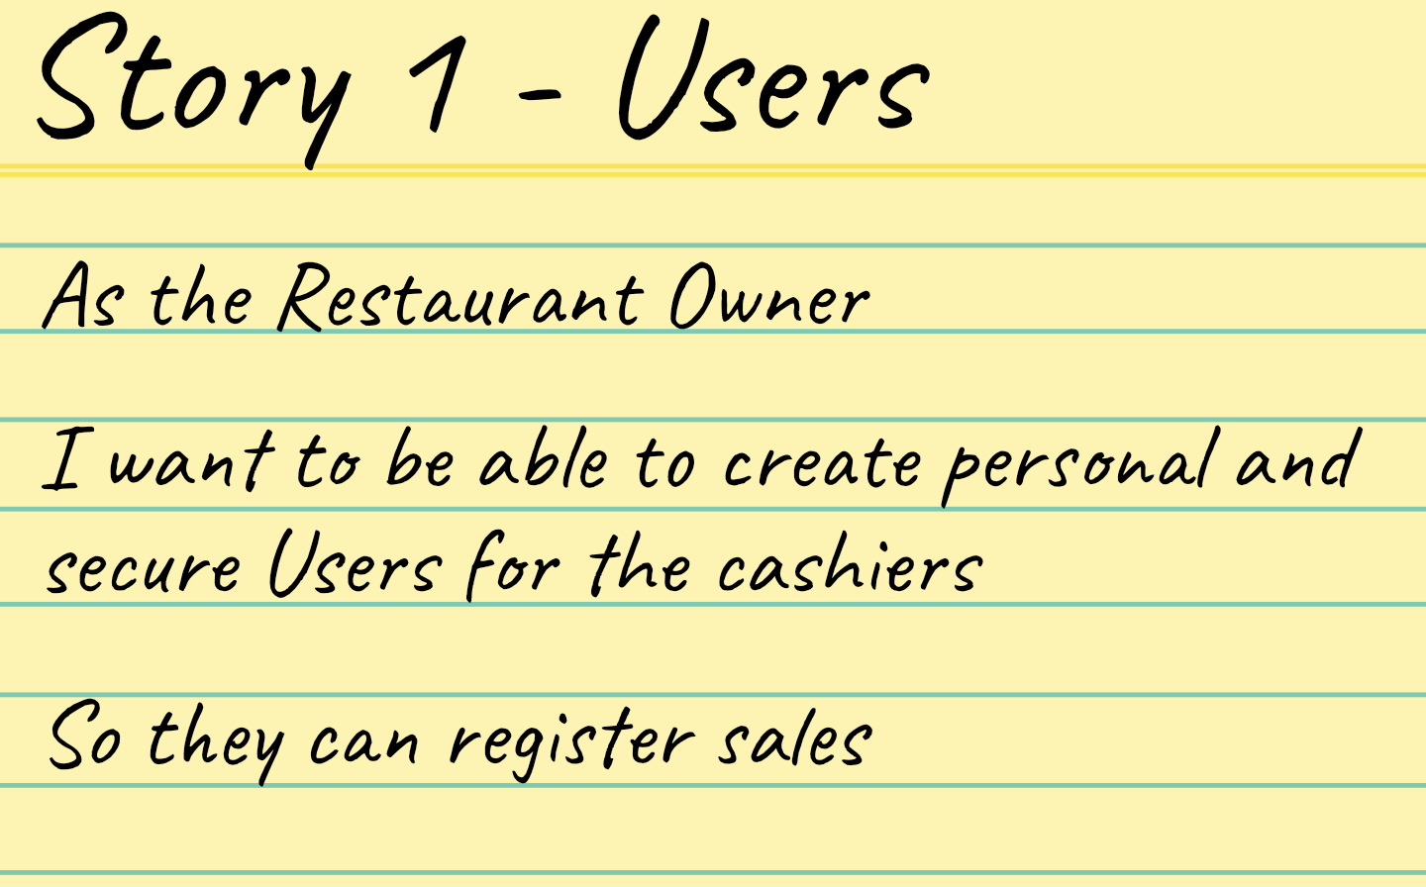

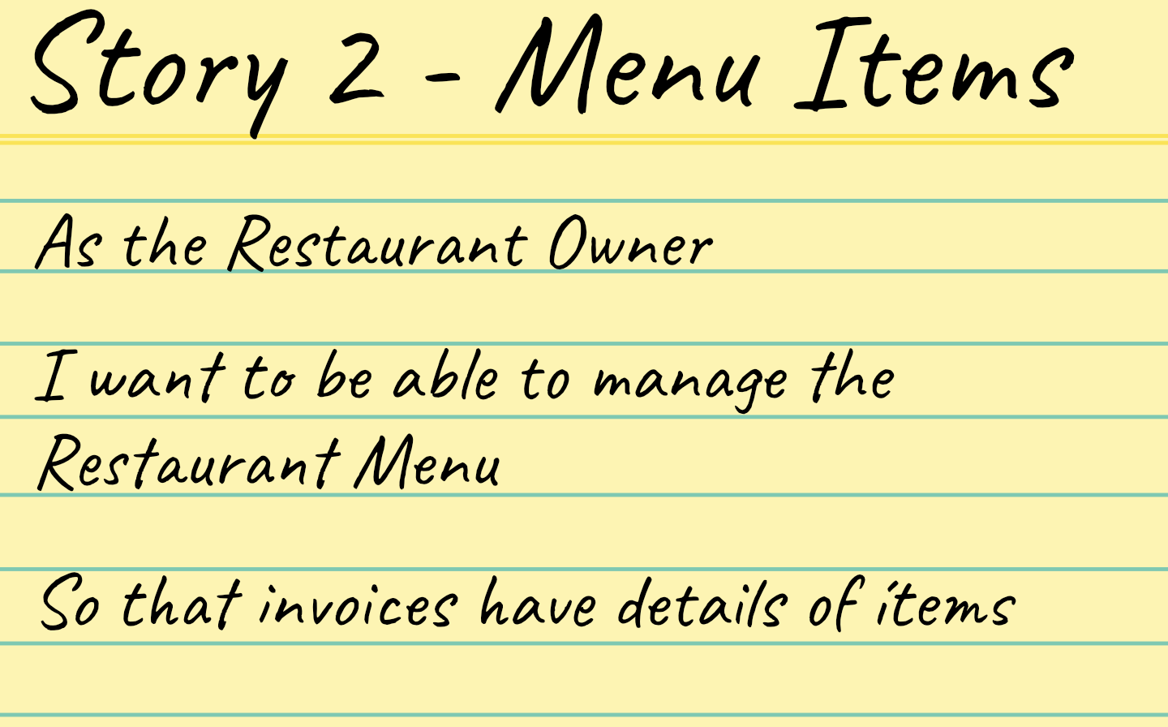

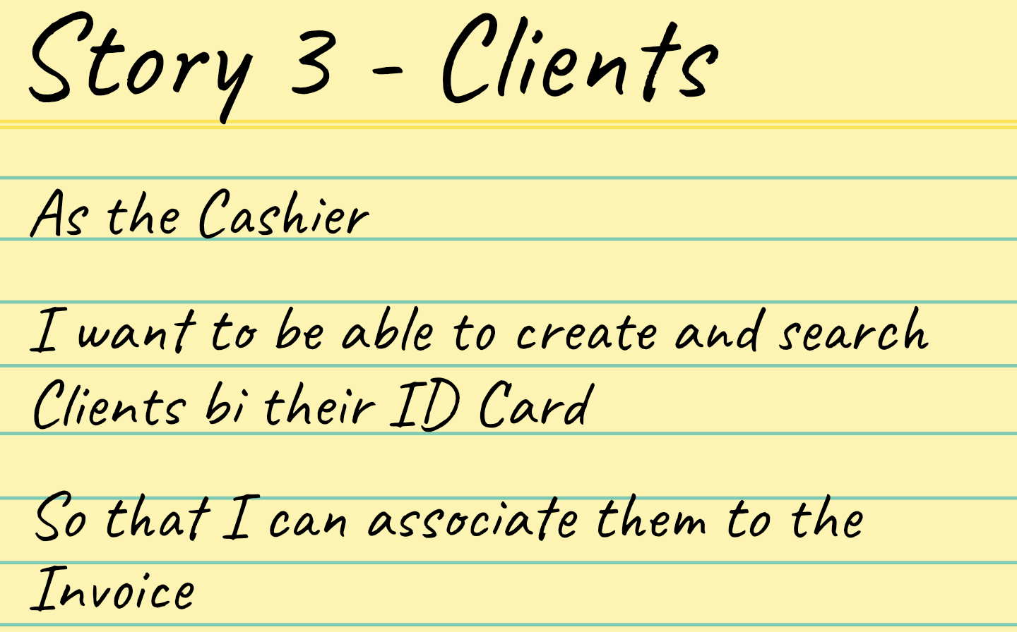

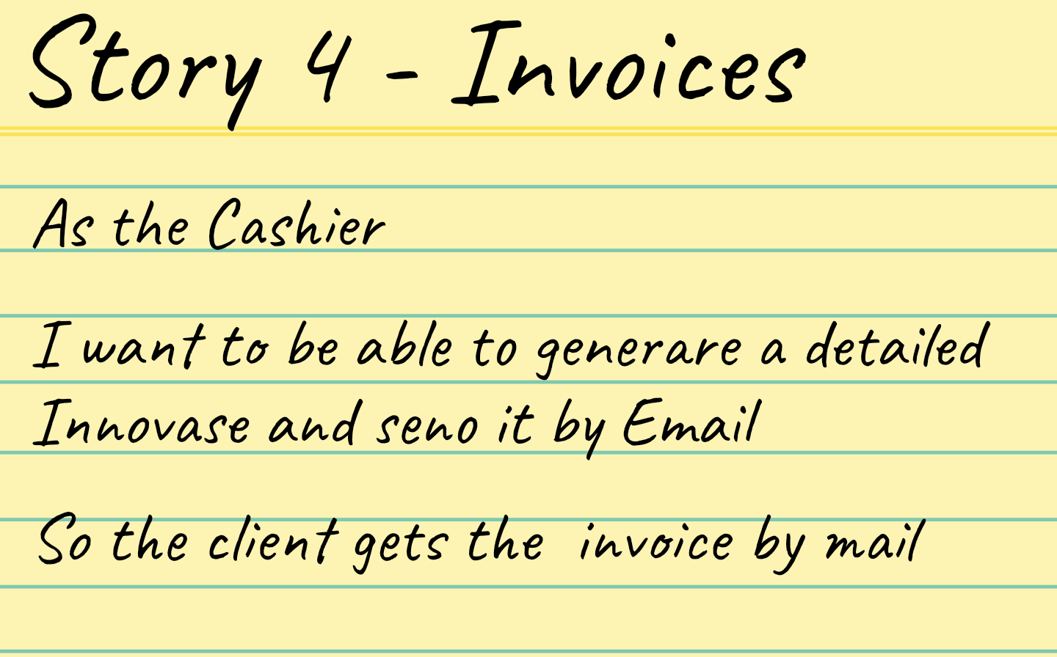

Based on this User Stories, we stablished 4 Business Rules that need to be implemented for the restaurant

***User Story 1 - Business Rule - Users****For the Users to be secure, their passwords can’t be saved as plain text on the database.  
We’ll use Bcrypt library to hash the passwords of new Users and we save these hashes which is secure in case someone gets that information.*

***User Story 2 – Business Rule - Menu Items****The Restaurant Owner wants to be able to give discounts to specific clients to engage them. So, we want a Service that allows us to Send a discount on an specific item of the menu, to an specific client, and for and specific percentage and we will use WhatsApp.*

***User Story 3 – Business Rule - Clients****The Restaurant Owner wants to have a report of how many times a client has bought on the restaurant, and how much he has spent.*

***User Story 4 – Business Rule - Invoices****We want to be able to send any invoice again to the Clients’ email address. We just need the Invoice Number to trigger this action.*